LOMAS Barefoot Bootcamp
El Dorado Maroma
AUG 17, 2026
We are pleased to advise that The FAN networking is now partnering with LOMAS Hospitality, owners of Lomas Travel and the El Dorado Resort collection, to provide networking & training in their award winning resorts!
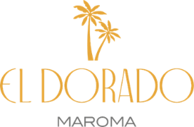
Our LOMAS premier event will be at El Dorado Maroma, their multi award winning boutique size resort, located on world famous Maroma Beach. This property is home to El Dorado Maroma, Maroma Adventures/Beach Club and Palafitos Overwater Bungalows.
Our visit/day pass will include a brief site inspection at El Dorado Maroma as well as the Palafitos, a presentation of the Lomas Hospitality wedding & vow renewal possibilities and a day pass to Maroma Beach. Included will be lunch at the beach restaurant-with open bar, sun loungers and a whole lot of networking fun in the sun! (From 11am-5pm)
** Space is LIMITED for this event **
This event is at no additional charge for Fan Networking Members with active memberships!
* The Maroma Beach pass is usually MX1800 per person *
FAN Memberships are available for 1 month, 3 months & 6 months Membership application/profile and membership dues schedule at this link--
https://sl1nk.com/f4929z8
Carl Howard, the Fan Networking US Phone +1 678 920-5294 Whats App +52 984 167 8269
Email Pepe Pepe@travel-with-pepe.com

